**Segment cells manually in 3D using TrackEM2**

*(For more details on TrackEM2:* [*http://www.ini.uzh.ch/~acardona/howto.html*](http://www.ini.uzh.ch/~acardona/howto.html) *)*

You will need

* a 1 –color z-stack of the data you want to segement (not sure it can handle multi channel stacks).
* The dimensions in nm of the voxels in x,y,z (can be found under Image > Properties > Pixel width, Pixel height, Voxel depth for some microscope data; otherwise you should always have it logged with your data).

**1) Start a TrackEM2 project by clicking File>New>TrackEM2 (blank)**

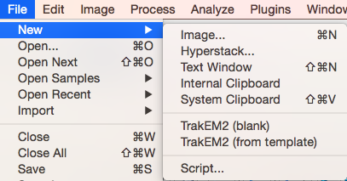

**Select the storage folder where the results will be saved.**

I encourage saving the analysis along with the data, using for each folder a name that is easy to connect to the input data, e.g.



2 windows will appear:

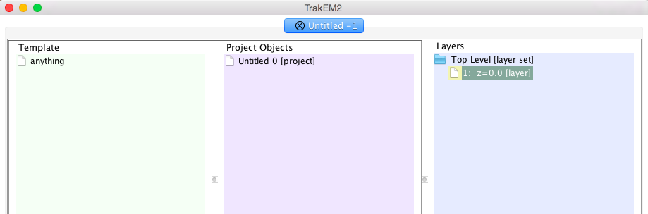

and

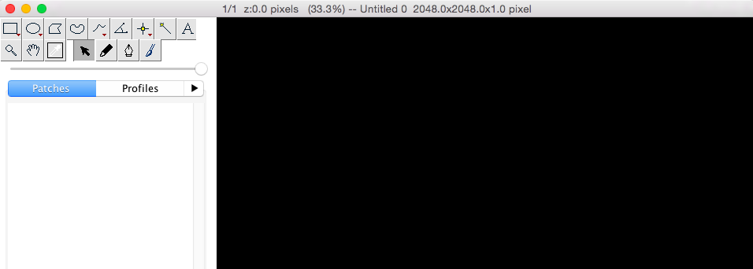

**2) Load data stack into TrackEM2**

Under Layers>Top Level > 1: z = 0.0 [layer], right-click > Import stack…

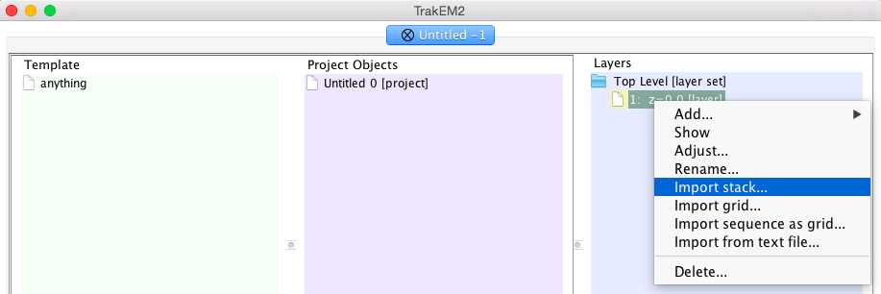

**Select the file holding your z-stack**

Make sure the z separation matches the ratio between the size of the voxels in x,y and z (here for 103.8 nm x 103.8 nm and 500 nm z-separations, you would enter 4.81). Make sure to import the stack as One slice per layer (Patches):

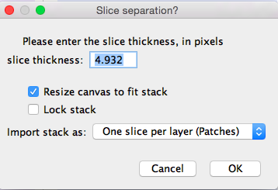

You might get an error message, not sure it is important, click ‘yes’ anyway.

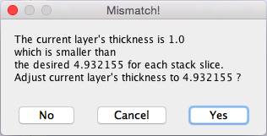

The slices (called layers in TrackEM2) will now appear in the Layers panel:

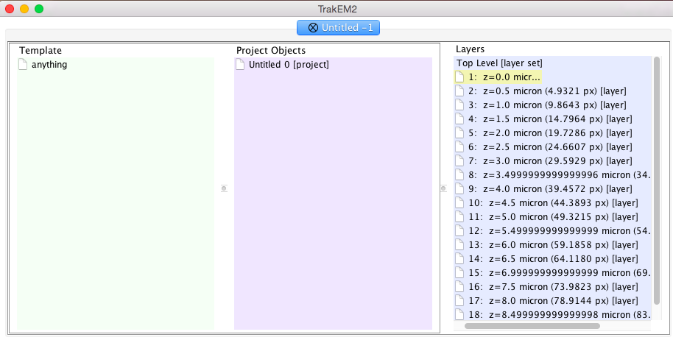

Also, the data will be visible in the navigation window of TrackEM2:

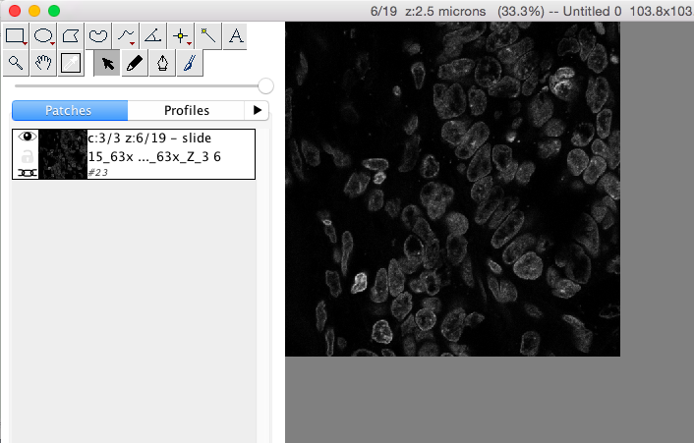

You can scroll through the z-planes using the shortcuts < and >.

**3) Rename Project**

right-click onto Untitled 0 > Rename, choose a name that describes the data, e.g. “Nuclei”

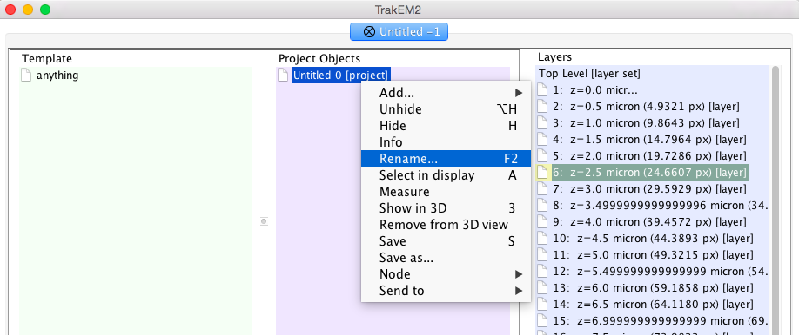

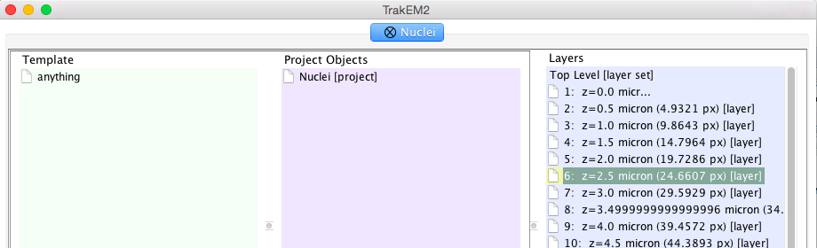

**4) Add a new child under your project**

right-click Nuclei > Add… > new anything

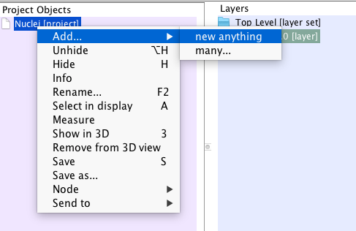

Rename as you see fit (I renamed mine ‘nuclei area lists’):

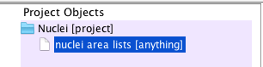

**5) Create an area list under template**

right-click on ‘anything’ under Template > Add New Child > area_list

Area lists are one of the many annotation types you can generate with TrackEM2. They consists of a list of regions that you can manually paint on each slice. All the regions from a single object (nucleus) are entered at the same time to eventually generate a discrete volume. For other types of objects, e.g. membranes, there might be more suited templates.

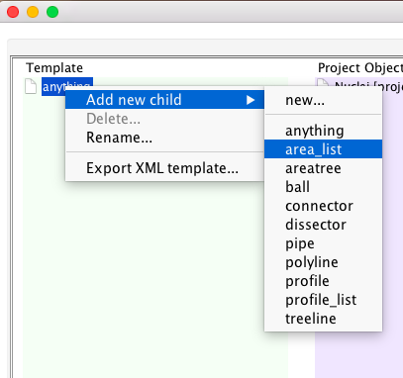

A blue folder icon will appear to the left of ‘anything’. Double click on the folder icon to reveal the newly added area_list entry:

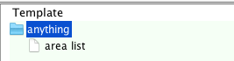

**7) generate the first area_list object**

Drag ‘area list’ from the Template panel into your project child (‘nuclei area lists [anything]’ here):

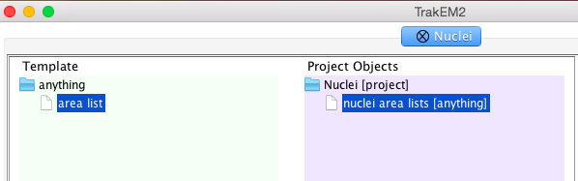

This will make an object appear under ‘nuclei area lists’. This is the entry that refers to your first segmented nucleus (not sure how the numbering is generated)

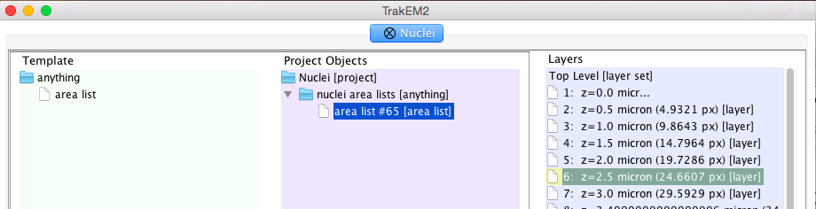

**8) Start segmenting manually**

The area list segmentation tool is a paint brush.

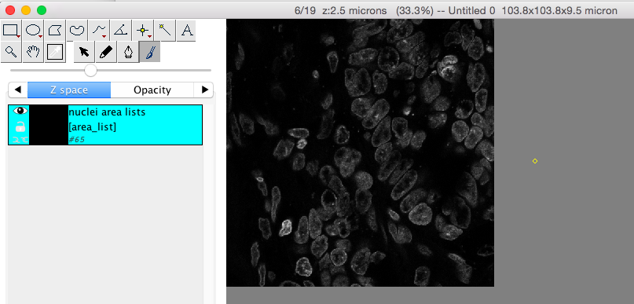

You can adjust the brush size by holding shift while scrolling (two finger scroll on mac) – you will see intermittently the size of the brush overlaid when you adjust it:

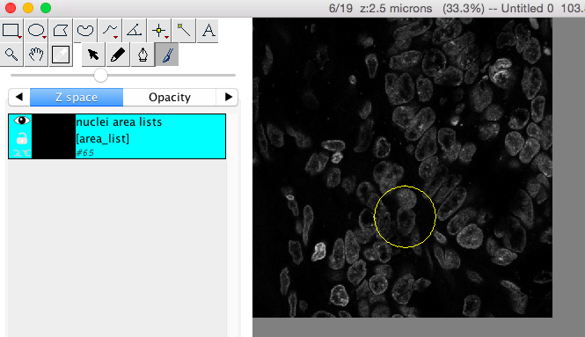

The zoom level can be adjusted with the usual shortcuts (cmd +; cmd – on mac). The below view is my typical comfortable setting of zoom/brush diameter:

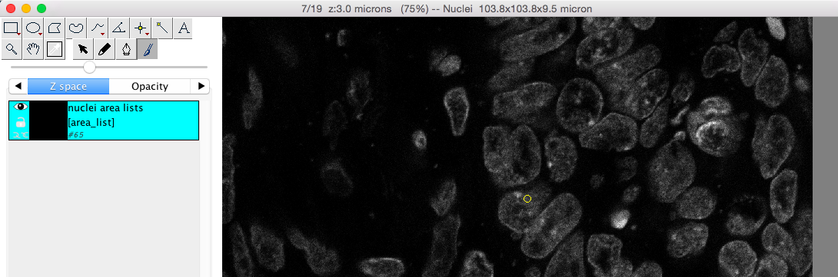

start painting one nucleus:

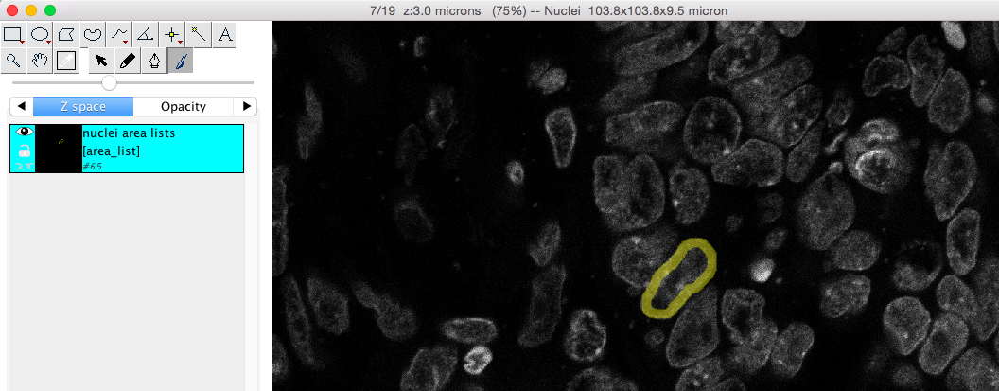

if a contour is painted, shift click inside to automatically fill it up:

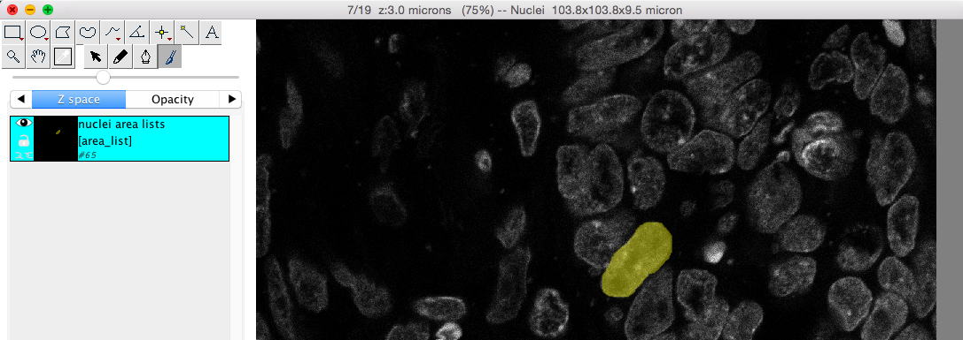

Once you are done with one z-slice, navigate to the next layer (using < or >) and repeat the segmentation of the same nucleus:

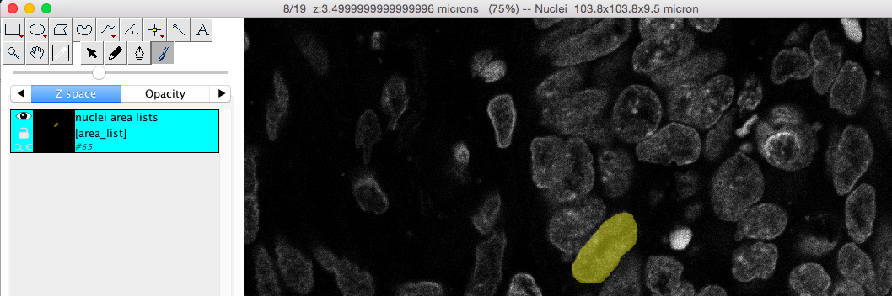

continue up to the last slice at which the nucleus is in focus:

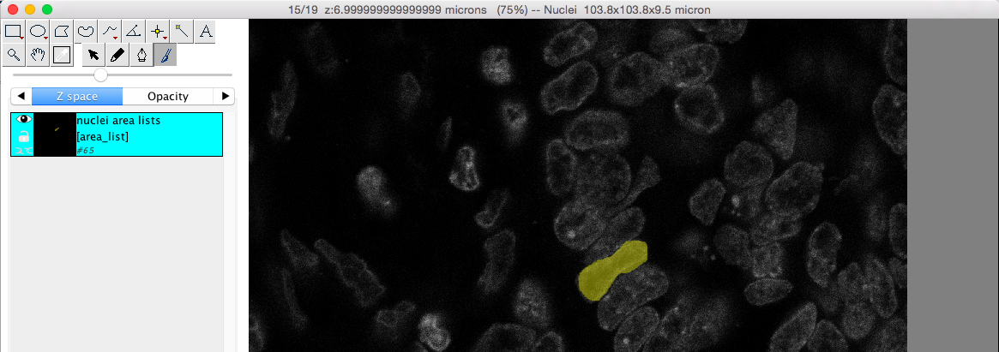

and make sure to go back to the first slice at which the nucleus is in focus:

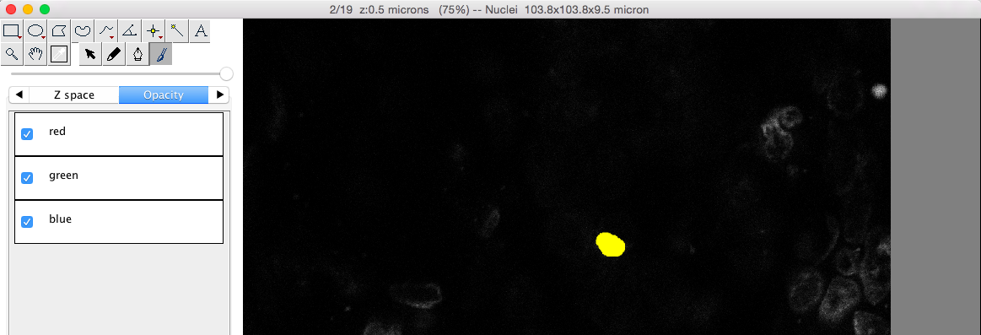

Once the nucleus is completely painted, generate a second nucleus by click and dragging and area_list from the Template panel to the ‘nuclei area lists’ entry in the ‘Project Objects’ panel. A second entry will appear:

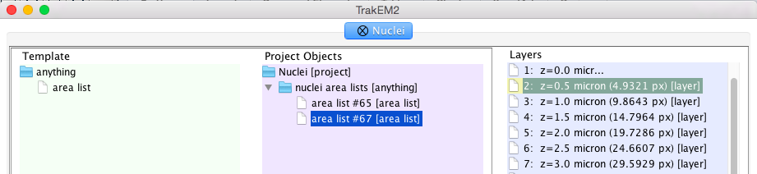

Now you can start painting another nucleus:

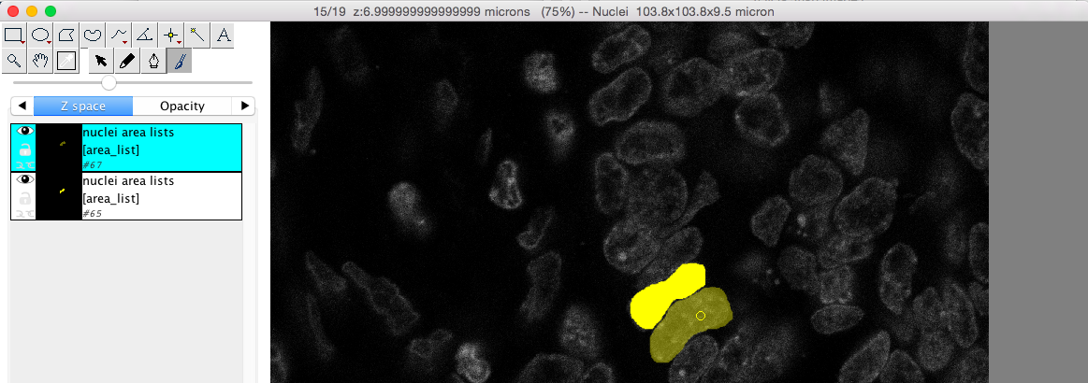

You can change the color (right-click on image > Color…) to make it visually easier:

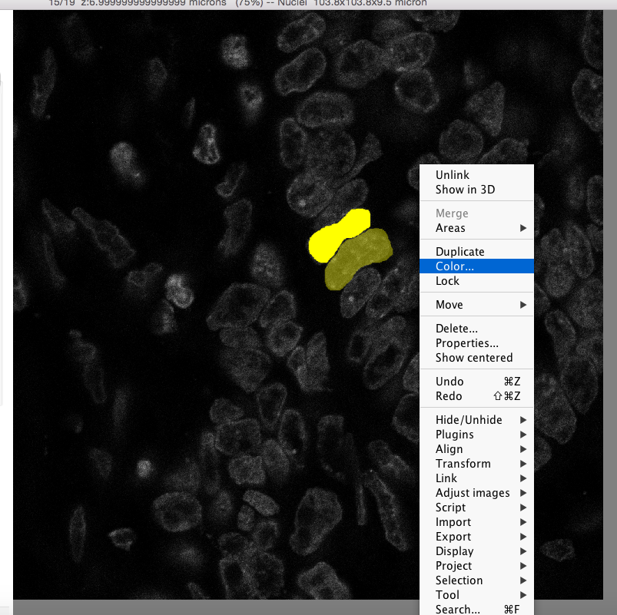

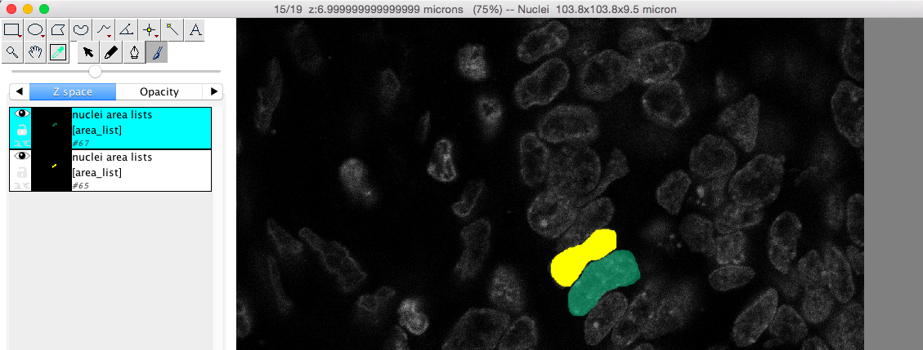

Segment the second nucleus over all the layers…

**9) Export the segmented objects as a stack:**

right-click (over the list of area_lists at the left of your image) > Export > Arealists as labels (tif)

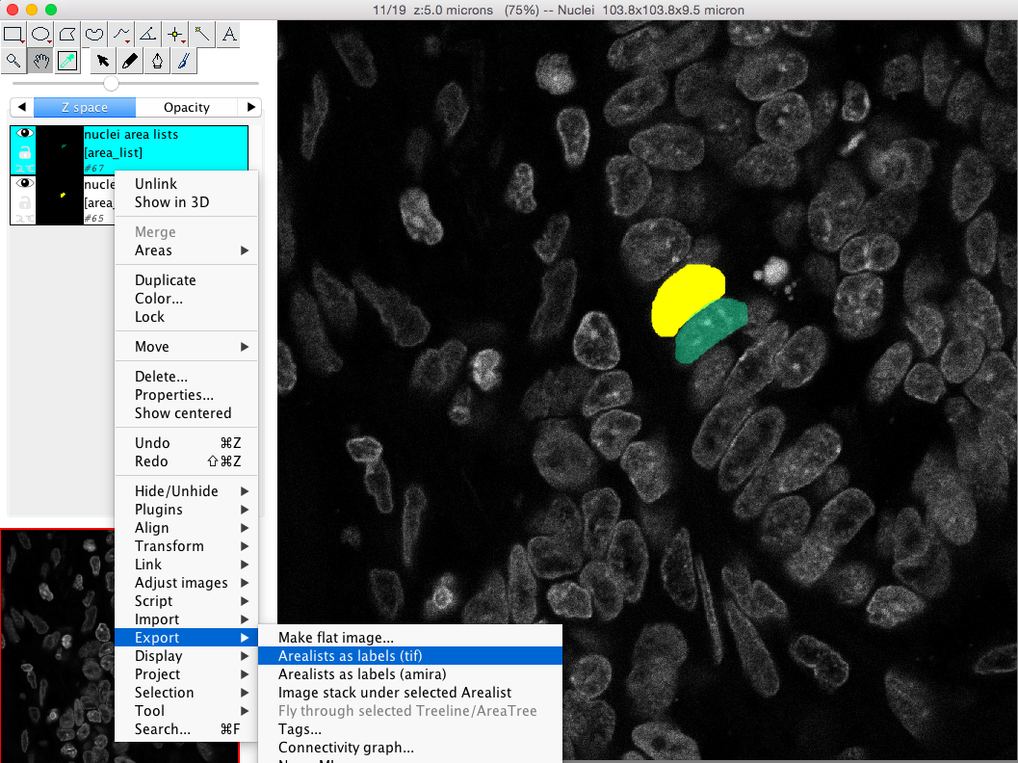

Make sure the entire range of the z-stack is included (or adjust range as desired):

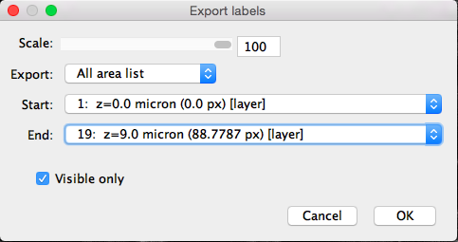

This will generate a gray-level image stack in Fiji where each nucleus is labeled with a unique number (make sure to adjust the contrast to see them).

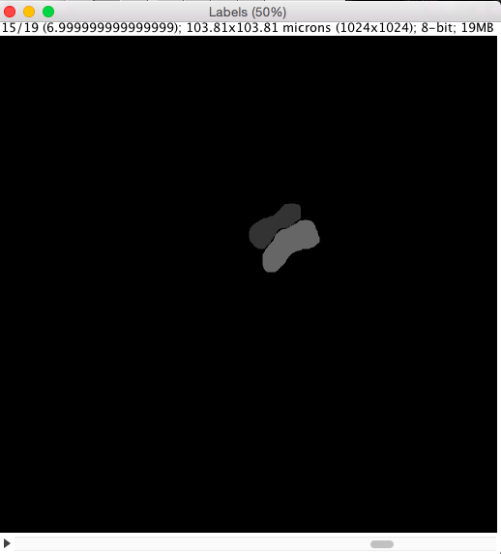

When many nuclei are segmented, It can be hard to select adequate gray scales to see them all easily, I recommend using a glasbey inverted Look Up Table. The glasbey look up table is a LUT structured in a maximally discontinuous manner:

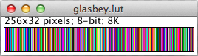

It is ideal for this type of application to ensure neighboring objects (usually with similar values) are visually distinct.

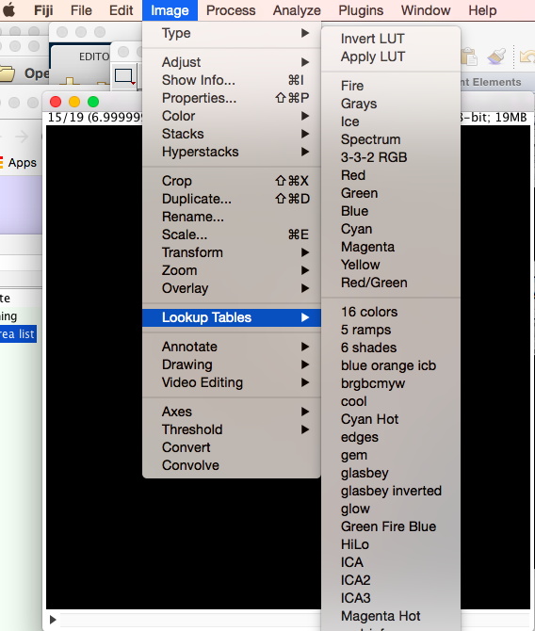

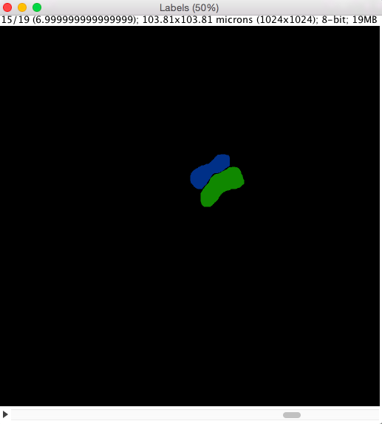

Make sure to save the Labels stack in your data folder with a name that links it to the original data file, e.g. by using the same file name with a descriptive suffix - in our case:

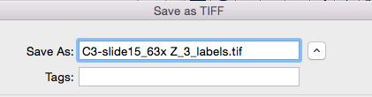

**10) Visualize the data in 3D**

Plugins > 3D Viewer

